IEF Scholarship Application Procedures
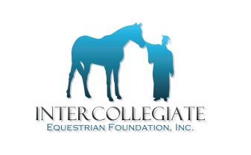

Intercollegiate Equestrian Foundation, Inc.
18 Crown Lane; Greenwich CT 06831

The following details the process and the required submission dates for both Intercollegiate Horse Show (IHSA) members and non-members.

Important: Packages which are LATE or INCOMPLETE will not be considered.

APPLICANTS:

IHSA MEMBERS and NON-MEMBERS:
IHSA individual members should obtain the application form from www.ihsainc.com, or directly from the IEF at iefapplication@gmail.com.

ALL completed application materials and transcripts MUST and all related materials must be submitted directly to I.E.F. at the address below.

Deadline for submission of completed package to IEF is February 23, 2018. IEF must RECEIVE applications and all related materials by February 23, 2018 for consideration. Applications with a postmark later than February 22nd will not be considered.

Lisa A. Bailey
18 Crown Lane
Greenwich CT 06831
Telephone Contact: 203-337-6477
Email Contact: iefapplication@gmail.com

