2016 IHSA National Finals
THE ALLTECH ARENA LEXINGTON, KENTUCKY
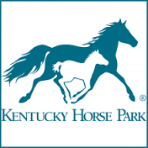
MAY 5-8, 2016

PLACE AN AD IN THE SHOW PROGRAM
SEND ADS TO MAJORIE YEAGER AT MYeager78@hotmail.com
RESERVE SUITE OR RINGSIDE SEATING
CONTACT BILL YEAGER AT
WYeager3@hotmail.com
SPONSORSHIP OPPORTUNITIES
CLASS SPONSORSHIP JUMP SPONSORSHIP HORSE SPONSORSHIP
Contact Bill Yeager WYeager@hotmail.com
OTHER SPONSORSHIP OPPORTUNITIES AVAILABLE:
CONTACT Peter Cashman peter.cashman@usma.edu

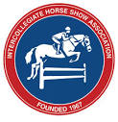 www.ihsainc.com 