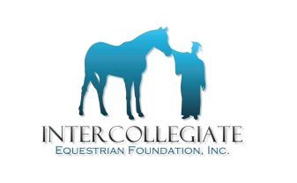
2016 IEF SCHOLARSHIP NOTED AWARD WINNERS

Joan Johnson Memorial Award
Sabrina Fox
Mount Holyoke College
Zone 1 Region 3

Emily Hilscher Memorial Award
Micah Armbrust
Liberty University
Zone 4 Region 5

Jack Fritz Memorial Award
Emily Watson
Murray State University
Zone 5 Region 1

Jane Flynn Memorial Award
Aleena Karamally
University of California, San Diego
Zone 8 Region 2

J.T. Tallon
Cassandra Steptoe
Liberty University
Zone 4 Region 5

Lindsey Phibbs Memorial Award
Lindsay Rovinelli
University of Ottawa
Zone 2 Region 2

Zone 7 Scholarship Award
Annise Montplaisir
North Dakota State University
Zone 7 Region 3

2016 LISTING OF IEF SCHOLARSHIP WINNERS
ZONE REGION FIRST/LAST NAME COLLEGE/UNIVERSITY
1 | 2 | Gillian | Kramer | Bowdoin College
5 | 1 | Ashley | Wheeler | Tennessee Technological University
5 | 1 | Holly | Evans | University of Tennessee, Knoxville
5 | 2 | Sheila | Palmer | Judson College
5 | 3 | Hannah | Bentz | College of Charleston
5 | 5 | Allison | Unger-Fink | University of Florida
6 | 2 | Sydney | Thompson | Miami University
6 | 2 | Emily | Simanskis | Miami University
6 | 2 | Lexie | Renner | Wilmington College
7 | 2 | Hannah | Ellis | West Texas A&M University
7 | 2 | Ashlyn | Tyk | West Texas A&M University
7 | 5 | Kelsey | Macke | Illinois State University
7 | 5 | Brandi | Feehan | Kansas State University
7 | 5 | Alex | Miller | Black Hawk College
8 | 2 | Chelsea | Fishenfeld | California Polytechnic University, Pomona
8 | 5 | Allyson | Dorrell | Colby Community College
8 | 5 | Alissa | Martindale | University of Nebraska at Lincoln

