IEF Scholarship Application Procedures
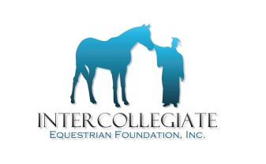

Intercollegiate Equestrian Foundation, Inc.
18 Crown Lane; Greenwich CT 06831

The following details the process and the required submission dates for both Intercollegiate Horse Show (IHSA) members and non-members. It is important to note that the process is different based upon whether you are an IHSA member or not. Please follow the appropriate procedure.

Important: Packages which are LATE or INCOMPLETE will not be considered.

IHSA MEMBERS:

IHSA individual members should obtain the application form from www.ihsainc.com, an IHSA member coach, the President College of a region, an IHSA member college Financial Aid Office or directly from the IEF at lisabaileycassidy@gmail.com.

IHSA MEMBERS MUST submit completed application package to your Region President Representative in your IHSA Region. DO NOT MAIL APPLICATIONS DIRECTLY TO IEF, THEY WILL NOT BE CONSIDERED.

Deadline for submission of completed package to President College: February 10, 2016. Region presidents must RECEIVE applications and all related materials by February 10, 2016 for consideration. In some cases, transcripts are sent directly to IEF, which is acceptable.

REGION PRESIDENTS: Once you have reviewed the applications for completeness, you need to forward by registered or express mail to the IEF. All applications must be received by the IEF from each of the REGION PRESIDENTs no later than February 24, 2016.

Region Presidents should send all applications via registered or express mail to:

Lisa A. Bailey
18 Crown Lane
Greenwich CT 06831
Telephone Contact: 203-337-6477
Email Contact: lisabaileycassidy@gmail.com

NON-IHSA MEMBERS:

Non- IHSA members should obtain the IEF scholarship application form from www.ihsainc.com or by directly requesting an application from IEF.

Non-IHSA MEMBERS MUST submit completed application and transcripts and all materials directly to I.E.F. at the address below. See deadlines and mailing instructions below.

Non-IHSA members should mail or express mail (do not email) completed applications and pertinent and related materials to be received by February 10, 2016 directly to:
Lisa A. Bailey
18 Crown Lane
Greenwich CT 06831
Telephone contact: 203-337-6477
Email contact: lisabaileycassidy@gmail.com

